

**Start pages**

**“BUSINESS ANALYTICS IN FINANCIAL DEPARTMENT**

**ACTIVITIES IN AIRPORTS AUTHORITY OF INDIA"**

**MASTER OF BUSINESS ADMINISTRATION**

**SEMESTER III**

**SUBMITTED**

**IN PARTIAL FULFILLMENT OF THE REQUIREMENTS**

**FOR**

**THE AWARD OF DEGREE OF**

**MASTER OF BUSINESS ADMINISTRATION**

**Andhra University School of International Business(AUSIB),**

**Andhra University South Campus, Visakhapatnam,**

**Andhra Pradesh, 530003, INDIA.**

**CERTIFICATE**

Certified that the Internship project in Finance and Accounts Department, Airports Authority of India presented by Mr. Janakiram, M.B.A. (Business analytics), School of International Business of Andhra University represents his original work which was carried out by us at Finance and Accounts Department, AAI visakhaptanam under my guidance and supervision during the period from 13.12.2024 to 21.01.2025.

Name of Guide/Mentor:

N. SUSHMA, HOD

Signature of Guide:

Date: 25.01.2025

**DECLARATION**

I M. JANAKIRAM, hereby declare that the work presented in this project report, titled “Financial Analysis (Crebit Risk Analysis) in Financial Management Activities at Airports Authority of India,” is the result of my sincere efforts and learning experience during my internship at the Airports Authority of India (AAI). This project was carried out under the guidance of Shri N Sivaji, Asst. General Manager (Finance).

I affirm that the data collected, analysis performed, and insights derived in this report are authentic and presented in bona fide spirit. I have not submitted this work, in whole or in part, to any other institution or authority.

This project is submitted as a part of my academic learning at Andhra University.

Janakiram Andhra University Reg.no823207502073

**ACKNOWLEDGEMENT**

I am grateful to Andhra University for giving me an opportunity to showcase my interest and talent in the form of this internship project. I am also thankful to the entire management of School of International Business for making all the facilities available on time.

The success of my internship largely depends on the encouragement and guidelines of Shri K Shankara Rao, Senior Manager (F&A), my project guide who guided me despite their very hectic schedule. Without their Support and Guidance this project would not have been completed.

I am extremely honourest and privileged to have Prof. N SUSHMA, having guidance at Andhra University School of International Business. I am very thankful for her continuous guidance and support throughout the internship as well as her help in aducational aspects.

**ABSTRACT**

This study explores financial analysis with a focus on credit risk assessment in the Financial Management Activities of the Airports Authority of India (AAI), Visakhapatnam Airport. It examines the financial statements of AAI, applying various analytical methods such as ratio analysis, trend analysis, and cash flow evaluation to assess the organization's financial health and stability. The research highlights AAI’s revenue structure, risk factors, and creditworthiness, providing insights into its financial performance. The study also discusses the impact of privatization, regulatory changes, and macroeconomic factors on AAI’s financial position. Tools such as Microsoft Excel, Power BI, and Tableau were used for data analysis, enhancing the visualization and interpretation of financial data. The findings suggest that AAI maintains a stable financial outlook, supported by sovereign backing and a diversified revenue model, despite operational and regulatory challenges.

**Table of Content**

|  |  |  |
| --- | --- | --- |
| **Sl. No** | **Name of The Topic** | **Page No** |
| **1** | **Certificate** | **3** |
| **2** | **Decleration** | **4** |
| **3** | **Acknowledgement** | **5** |
| **4** | **Abstract** | **6** |
| **5** | **Profile of Airports Authosrity of India** | **11** |
| **6** | **Introduction to Financial Statement Analysis** | **26** |
| **7** | **CREDIT RISK ANALYSIS** | **33** |
| **8** | **Conclusion** | **40** |



The Visakhapatnam International Airport was initially an Indian Navy Airbase called INS Dega. It started operating as a civil airport only in 1981.

* **Runway**

The original runway was 6,000 ft long, but a new 10,007ft runway was inaugurated in 2007.

* **Terminal**

A new terminal building was inaugurated in 2009 and became operational later that year.

* **Instrument landing system** The ILS was installed on Runway 28 and became operational for commercial aircraft in 2008.



भारतीय विमानपत्तन प्राधिकरण

AIRPORTS AUTHORITY OF INDIA

|  |
| --- |
| ध्येय |

विमान यातायात सेवाओं एवं हवाई अड्डा प्रबंधन में नेतृत्व करते हुए विश्वस्तरीय संगठन बनाना एवं 2016 तक एशिया प्रशांत क्षेत्र में भारत को एक प्रमुख केन्द्र बनाना।

**Vision**

To be a world-class organization providing leadership in air traffic services and airport management and making India a major hub in Asia Pacific Region by 2016.

|  |
| --- |
| उद्देश्य |

राष्ट्र के आर्थिक विकास और समृद्धि में योगदान करते हुए ग्राहक की सम्पूर्ण संतुष्टि के लिए अत्याधुनिक अवसंरचना उपलब्ध कराते हुए विमान यातायात सेवाओं और हवाई अड्डा प्रबंधन में सुरक्षा एवं गुणवत्ता के उच्चतम स्तर प्राप्त करना।

**Mission**

To achieve highest standards of safety and quality in air traffic services and airport management by providing state-of-the-art infrastructure for total customer satisfaction, contributing to economic growth and prosperity of the nation.

FINANCE DEPARTMENT

Whenever you fly, you are in safe hands of AAI



PROFILE

OF

AIRPORTS AUTHORITY OF INDIA

BY FINANCE DEPARTMENT



**1. PROFILE OF**

**AIRTPORTS AUTHOSRITY OF INDIA**

**1.1 INTRODUCTION**

Airports Authority of India (AAI) came to existence on 1st April 1995. AAI has been constituted as a Statutory Authority under the Airports Authority of India Act, 1994. It has been created by merging the erstwhile International Airports Authority of India and National Airports Authority with a view to accelerate the integrated development, expansion and modernization of the air traffic services, passenger terminals, operational areas and cargo facilities at the airports in the country.

The main functions of the Authority are as under:-

Control and management of the Indian air space (excluding special user air space) extending beyond the territorial limits of the country as accepted by ICAO.

Provision of Communication, Navigational and Surveillance Aids.

Expansion and strengthening of operational areas viz. Runways, Aprons, Taxiways, etc. and provision of ground based landing and movement control aids for aircrafts & vehicular traffic in operational area.

Design, development, operation and maintenance of passenger terminals.

Development and management of cargo terminals at international and domestic airports.

Provision of passenger facilities and information systems in the passenger terminals.

AAl owns and maintains 125 airports comprising 68 operational airports, 26 Civil Enclaves, Le. Civil Air Terminals at Defence controlled airports**.**

where AAI handles civil flight operations and 31 non-operational airports. In addition, AAl provides Air Navigation Services (ANS) at all civil airports in the country. AAl manages the designated Indian air space measuring 2.8 million square nautical miles which includes land area measuring 1.05 million square nautical miles and oceanic airspace measuring 1.75 million square nautical miles. Air Navigation Services are also provided by the AAl at 9 other airports that are not managed by AAl namely Bangalore, Hyderabad, Cochin, Lengpui,

Diu, Latur, Mundra, Nanded and Sathya Sai Puttaparthy Airports, which are joint venture airports, State Government owned airports and private airports.

The Authority continued with its mandate of creating more airport infrastructure and navigation infrastructure across the length and breadth of the nation. Recently, New Terminal Buildings were commissioned at Chennai, Kolkata, Raipur, Ranchi, Bhubaneswar, and Puducherry airports.

**1.2 Development of Airport Infrastructure**

The passenger traffic, having witnessed herojector surge that decade placing the The passengeration sector on a high growth trajectory, increased from 37.0 million in 1995 96 to 159.40 million in 2012-13. This surge in traffic led to congestions at major airports affecting air safety and operational efficiency.

To enhance airport infrastructure in India, modernization of existing airport infrastructure in metro & non-metro cities and construction of greenfield airports were contemplated to bridge the gap between the available airport capacity and the projected demand. Resources being limited, strategies were evolved to augment and create airport capacity ahead of demand schedule at busy airports in an optimal manner by leveraging technology and adopting best management skills & practices including private sector participation in upgradation of airport infrastructure at airports in Delhi and Mumbai. Over the years, passenger handling capacity has increased from 72 million (FY-06) to 220 million (FY-13-14), Although growth in passenger traffic in last fiscal was negative, but it has shown signs of recovery in the present fiscal. There is 6.4% increase in passenger traffic from April 2013 to Feb 2014 over the corresponding period in FY 2012-13.

AAl has completed expansion and upgradation of two metro airports at Kolkata and Chennai Airports at the cost of Rs.2324 crores and Rs.2015 crores, respectively. Annual cargo handling capacity and efficiency of operations at Chennai Airport has been augmented to handle 11 lakh MT of cargo with the construction of new modern Import Cargo Complex equipped with Automatic Storage Retrieval System at a cost of Rs.144 crores.

Development of selected 35 non-metro airports has been undertaken by AAl which are identified based on the regional connectivity, development of regional hubs, places of major tourist attraction and potential for development as business hubs. Projects at 32 airports have been completed. In the current financial year (FY 2013-14), new terminals have been commissioned at Chennai, Kolkata, Bhubaneswar and Ranchi airports and development at New Civil Enclaves completed at Bhatinda, Jaisalmer and Bikaner. Thus, AAl has amply demonstrated its commitment and expertise in creating world class infrastructure at our airports. All our major airports with impressive land mark terminals having state-of-the-art facilities are the gateway to economic of the city of their location.

**In line with the green building concept, utilization of renewable sources of energy and for sustainability, Solar Photo Voltaic Power Plants have been commissioned at Rajiv Gandhi Bhawan, New Delhi, airports at Raipur, Jaisalmer and Guwahati and work is awarded for Bhopal and Indore Airports.**

**1.3 Details of Projects**

**Projects Completed (Terminal Building & allied works)**

**Metro cities**: Chennai & Kolkata (Mega Projects)

**Non-metro cities:** Amritsar, Dehradun, Jaipur, Kullu, Srinagar, Udaipur, Varanasi, Gaya, Agra, Cooch Behar, Agartala, Barapani (Shillong), Dibrugarh, Lilabari, Ahmedabad, Aurangabad, Bhopal, Nagpur, Pune, Surat, Calicut, Guwahati, Madurai, Mangalore, Mysore (new aerodrome), Trichy, Trivandrum, Vizag, Chandigarh, Indore, Lucknow, Gondia (new aerodrome), Coimbatore, Jalgaon(new aerodrome), Raipur, Rajahmundry, Puducherry, Ranchi, Bhubaneswar and Goa (New Integrated Terminal Building).

**New Civil Enclaves** - Bhatinda, Jaisalmer and Bikaner

**Projects Nearing Completion (Terminal Building & allied works)**

Khajuraho and Kadappa.

**Projects in progress**

Tirupati, Chandigarh (Mohali side), Pakyong (Sikkim- new Greenfield Airport), Tezu (Arunachal Pradesh), Vadodara, Hubli, Belgaum and Kishangarh.

**Projects on the Anvil (New Terminals & Aerodromes)**

Port Blair, Jammu, Guwahati, Itanagar (new greenfield airport), Deoghar (Jharkhand), Kishangarh (Rajasthan), Leh (J&K), Jharsuguda (Odisha), Vijaywada (AP), Raigarh (Chattisgarh), Pantnagar (Uttranchal), Solapur (Maharashtra) Meerut, Muradabad, Faizabad, Agra (New CE), Allahabad (new CE), and Kanpur (New CE) in UP.

**1.4 CNS/ATM Infrastructure**

There has been continuous improvement in the Air Navigation Services in India and its commitment and consistency time and again in upgrading and installing the state of the art navigational facilities across the nation which has been recognized globally.

Implementation of new RADARS/ADS-Bs, operationalizing ATM Automation Systems/Data Link Communication across the country, Implementation of PBN Based procedures, Reduced Horizontal separation, on-line Flight Planning, NOCAS implementation are some of our notable achievements that have contributed immensely to enhance safety and efficiency of aircraft operations. The Kolkata automation System which is to be operationalised shortly, will be an enabler for Upper Airspace Harmonisation in Kolkata with immense potential for enhanced operational efficiency, fuel savings to the Airlines and reduction in Carbon emission. Our collaborative initiative- INSPIRE to reduce emission in the oceanic region and the Enroute Monitoring Agency for monitoring the safety in the oceanic region have gained international recognition. One of the dream- come true projects of Air Navigation Services is Research and Development Project that has taken off at Hyderabad and is making significant progress by taking up "Human in the Loop" Simulation Project.

Another milestone that AAl has achieved last year is operationalising GAGAN for enroute Another milestonen dian FIR for the suitably eduled Navigation making India one of the elite operations in the rid to transition to Satellite Based Navigation. Our important task on hand is to expedite the process of certification for Approach procedure with vertical guidance and designing flight procedures and passing on the benefits of vertical navigation through designing suitable equipped aircraft and reaping the benefits of enhanced safety and efficiency.

The crowning moment for Air Navigation Services dawned on 4th March 2014 when India won the prestigious ATC Janes Award 2014 in Madrid, Spain for the collaborative work on won themental protection through the group on addrabian Sea Indian Ocean ATS Coordination Group (ASIOACG). The Janes Award 2014 adds to our rich bag of International Awards in the form of Janes ATC Award 2012 for Upper Air Space Harmonization in Chennai FIR and the twin ATC Global Awards 2013 for overall ANS achievements and INSPIRE. The hat-trick of awards undoubtedly vindicates the emergence of Indian Air Navigation Services as a force to reckon with in the international aviation arena.

Our immediate focus areas for ANS would be to implement ATFM, Certification for GAGAN for APV, Implementation of integrated Air Traffic Simulator for bench-marking Controllers in the country and harmonisaing Upper Airspace in the Kolkata Region.

**1.5 Accolades**

* Airports Authority of India received various accolades key being -
* Janes International ATC Award 2014
* Two ATC Global Awards 2013 for Excellence in ANSP Management as well as for Strategic Advancement in Air Transport,

**Janes International ATC Award 2012** for excellence in CNS / ATM service.

India Pride Award 2013-14 for Excellence in Infrastructure & Development in the category of "Public Sector Undertaking - Central".

**New Integrated Terminal Building (NITB) at NSCBI Airport, Kolkata has won number of engineering excellence awards,** as below:

➤ "2nd Best Engineering Marvel for the year 2013' by 'Engineering Watch' Magazine.

➤ "2nd Most Impactful Engineering Marvel" by 'Engineering Watch' Magazine.

➤ Award for "Excellence in Built Environment 2013" by Indian Buildings Congress (IBC).

➤ Vishwakarma Award 2014 under category "Best Construction Projects" by Construction Industry Development Council (CIDC), [under Planning Commission, Govt. of India].

NSCBI Airport, Kolkata has been conferred with **'Best Improvement Award- Asia Pacific (First Place) by Airports Council International (ACI).**

New Integrated Terminals at Bhopal and Indore were declared as first and second best buildings for its optimal design and quality of steel work execution by the **institute of Steel Development and Growth 2012 (INSDAG)** under Ministry of Steel, Government of India in competition with buildings constructed in Government private sector.

Today's Traveller Award 2013 for "Excellence **in Development of Airport Infrastructure in India".**

**"Engineering Excellence Awards"** conferred by Engineering Watch Magazine for five AAI airports namely, Kolkata, Bhubaneswar, Raipur, Chennai and Ranchi, in various categories as under:

➤ New Integrated Terminal Building of NSCBI Airport, Kolkata -**2nd Best Engineering Marvel for the year 2013, and 2nd Most impactful Engineering Marvel.**

➤ New Integrated Terminal Building of Biju Patnaik Airport, Bhubaneswar -**Best Future-Ready Engineering Marvel.**

➤ New Expandable Modular Integrated Terminal Building, Raipur Airport **Public Choice Award**.

➤ New Integrated Terminal Building at Birsa Munda Airport, Ranchi- **Special Mention Awards.**

➤ New Domestic and International Terminals at Chennai Airport -**Special Mention Awards.**

AAl has received Hospitality India Award in the Category of "Best Infrastructure" for the year 2013.

Swami Vivekananda Airport, Raipur won National Tourism Awards for the year 2012-13 in the category "Best Airport (Rest of India)" conferred by Ministry of Tourism, Govt. of India.

On the CSR front, AAI won

* **"Golden Peacock Eco-Innovation Award 2012"**

* Times of India and Teflas "FRAME CSR AWARD" for the year 2012

**\* 3rd Asia Best CSR Practice Award 2013**

AAl's Lounge Magazine received -

* Best Magazine Award by Hospitality India for the year 2012

* Best Magazine Award by Hospitality India for the year 2013

AAl has been awarded **TRAINAIR PLUS Certificate** and **membership plaque by** **ICAO** which was received by Chairman, AAΙ.



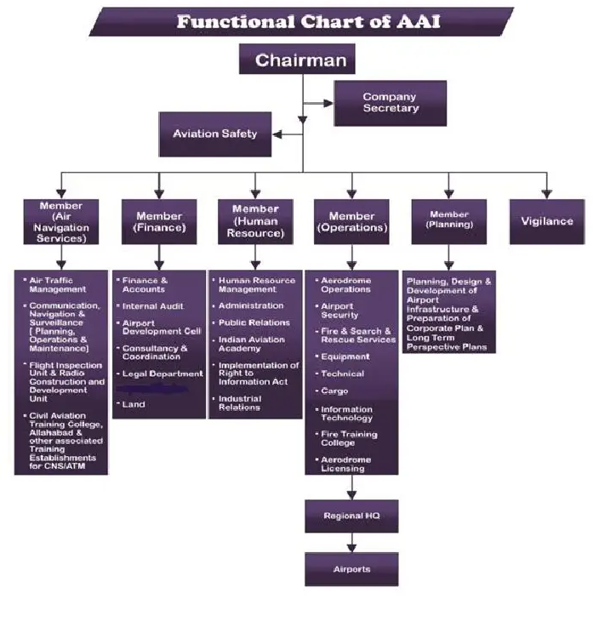 **1.6 THE FUNCTIONAL CHART OF AAI**



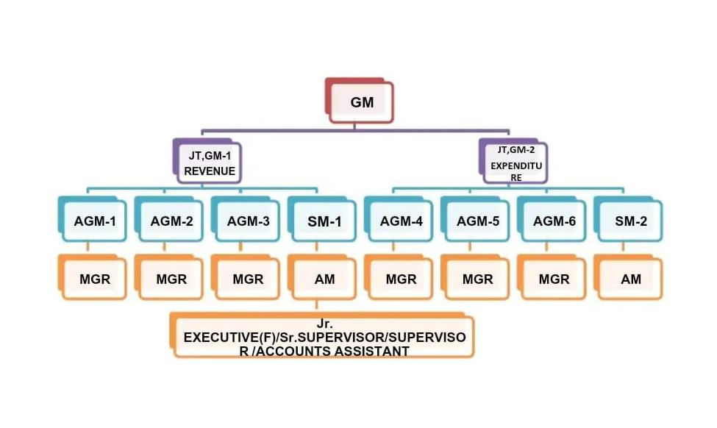 1.7 THE JOB LEVELS IN AAI**1.71 Responsibilities of Finance and Accounts**

* Cash and funds management
* Financial scrutiny of proposals/financial concurrence
* Formulation of proposal for tariff determination (Aeronautical charges)
* Formulation of Annual Revenue and capital Expenditure Budgets
* Maintenance of Cash book, Bank book, General ledger and Subsidiary ledgers
* Compilation of Annual Accounts
* Annual Report for AAI
* Introduction of appropriate accounting policies
* Compilation of Management Information Systems (MIS)
* Debtors Management
* Timely remittance of statutory and other deductions
* Timely filing of statutory returns as per Income Tax, Sales Tax, Service Tax, Service Tax, Foreign trade policy etc.
* Corporate Taxation & statutory levies
* Administration of CPF/Gratuity trusts/Pension
* Safe custody of financial instruments and timely actions for deposits and encashment etc.
* Monitoring of Joint Venture Companies
* Internal Auditing



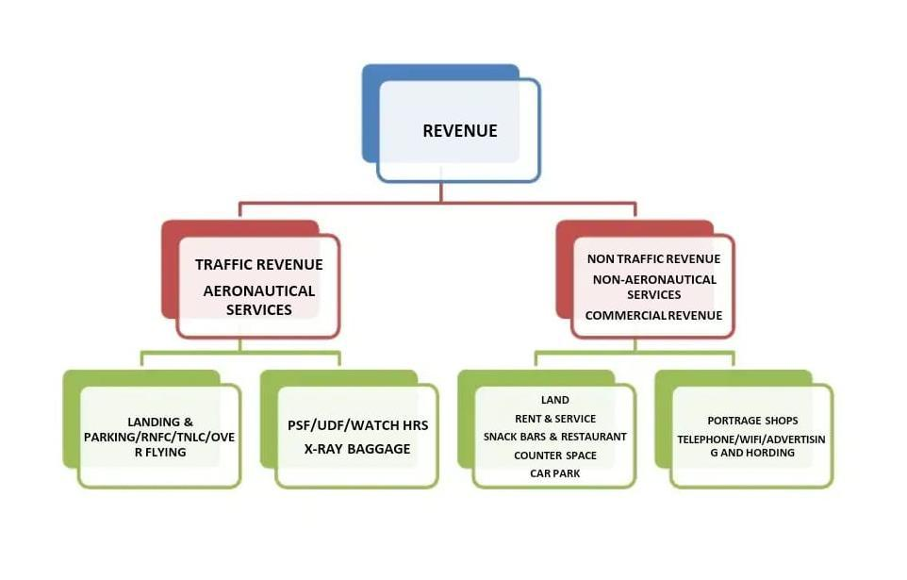 **1.8 REVENUE MODEL**

1.81 Responsibilities of Revenue Department

1. Creation of Bill to various Airlines & Concessioner in respect of Airport Services & Commercial Contract.
2. Transfer of Bill in respect of Foreign Airlines i.e. Landing & Overflying to IATA
3. Collection of Sundry Debtors
4. Bank Reconciliation.
5. Providing Credit Facilities to Aircraft Operator
6. Preparation of Revenue Budget
7. Reply of Audit Reports & Observation.
8. Provision of Bad Debts etc.
9. Main sources of revenue

Sources of revenue that accrue to AAI can be classified into three categories that are as following

1. Traffic Revenue

2. Non Traffic Revenue

3. Cargo Revenue

4. Airport Leasing Revenue

1. Traffic Revenue

**1. Route Navigation Facilities Charges**- This is charged for navigating the aircraft to its destination from the departed airport. Route navigation is also provided to all overflying aircraft in the Indian airspace. Basically, the charges are charged on weight (All Up Weight) of the aircraft and the distance flown. ATC Radar Controllers provide route navigation.

**Π. Route Navigation Facility Charges (RNFC)**

111. a) RNFC for Landing Flights:

IV. RNFCRs.(RxDxW)

V. R-Rs.4620/-

VI. D=(GCD/100) with GCD cap as 1200 NM

VII. W(AUW/50000) with AUW cap as 2,00,000 Kilograms

VIII. Abbreviations used:

IX .R=Service Unit Rate

X. D-Distance Factor

XI. W-Weight Factor

ΧΙΠ.GCD-Great Circle Distance in NM

ΧΙΠ.AUW All Up Weight of aircraft in Kilograms

XIV.b) **RNFC for Overflying = Rs.(R x D x W) + Rs. 4.400/-**

XV.c**) RNFC for Small Aircrafts registered in India:**

XVI.Route Navigation Facility Charges (RNFC) in respect of aircrafts with maximum All-Up Weight: -

XVII. (a) Up to 10,000 Kg's Shall be levied @ 20% of

the applicable rates of weight-cum-distance formula; and

XVIII.(b) More than 10,000 Kg's to 20,000 Kg's shall be levied @ 40% of the applicable rates of

XIX.weight-cum-distance formula

**II. Terminal Navigation Landing Charges**- This is charged for guiding the aircraft up to the point of touch down. TNLC is applicable at International airports and civil enclaves. Airports which are owned by Defence are categorised as civil enclaves. Generally, ATC Tower controller provides terminal navigation of the aircraft.

XX. a) Major International Airports including

Goa International Airport (Civil Enclave)

XXI. Weight of Aircraft For each landing /

Domestic flight/

XXII.International flights Amount in Rs.

XXIII.Below 10,000 kg's. 1087.90

XXIV. 10,000 kg's and above 6546.10

XXV. b) Civil enclaves (other than Goa International Airport)

XXVI. (i) International Flights

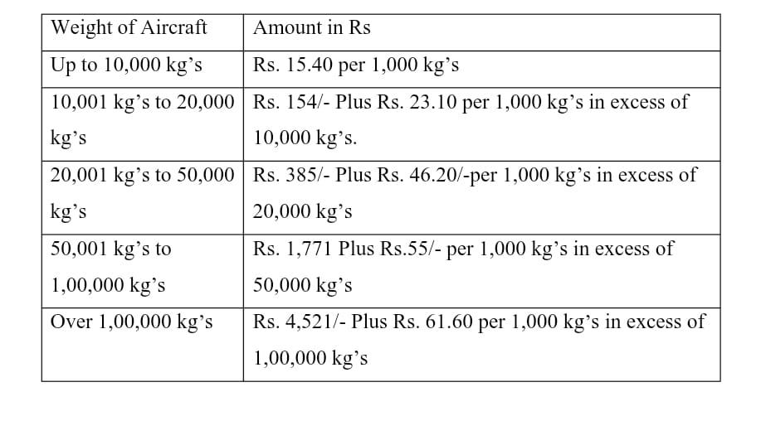

1. Landing charges- This is charged from the point of touchdown to its ultimate parking in the bay. Apron control guides the aircraft from the point of touch down to its ultimate parking in the bay.
2. Parking charges- This is charged for permitting the aircraft to be parked and a half hour in the aprons.
3. Housing charges- This is charged for permitting the aircraft to be parked inside the hanger owned by AAI.
4. Passenger service fees- this is charged for the facilities provided in the terminal as well as for the security arrangements at the airports. The same is collected from all embarking passengers at specified rate from time to time. Bills for PSF are to be raised based on the passenger manifest submitted by the Airlines.
5. User development fee- UDF is charged to cover any deficit in revenues so as to ensure fair return on investment. Bills for UDF are to be raised based on the passenger manifest submitted by the Airlines.

**2. Introduction to Financial Statement Analysis**

Financial statement analysis is a critical process in evaluating the financial health and performance of a project. It involves examining financial data to assess profitability, liquidity, efficiency, and overall viability. By analyzing key financial statements—the income statement, balance sheet, and cash flow statement—stakeholders can make informed decisions regarding investments, risks, and project sustainability.

**2.1 Purpose of Financial Statement Analysis**

1. Assess Financial Health – Evaluates whether the project is financially stable and profitable.

2. Support Decision-Making – Helps investors, lenders, and management make strategic choices.

3. Identify Risks and Opportunities – Highlights potential financial risks and areas for improvement.

4. Monitor Performance – Tracks financial progress against budgets and forecasts.

**2.2 Key Methods of Analysis**

* Ratio Analysis – Measures financial performance using liquidity, profitability, and efficiency ratios.
* Trend Analysis – Compares financial data over time to identify growth patterns.
* Vertical & Horizontal Analysis – Examines financial statements for structural changes.
* Cash Flow Analysis – Evaluates how well the project manages its cash inflows and outflows.

By conducting financial statement analysis, project managers and stakeholders can ensure that the project remains financially viable and aligns with strategic objectives.

**2.3 Need for the Study**

Financial statement analysis is essential for understanding a project's financial viability, stability, and future growth potential. The need for this study arises due to the following reasons:

**1. Investment Decision-Making** – Helps investors and stakeholders determine whether a project is financially viable and worth funding.

**2. Risk Assessment** – Identifies financial risks such as liquidity issues, debt burden, or profitability concerns.

**3. Performance Evaluation** – Measures how effectively the project utilizes resources and generates returns.

**4. Regulatory Compliance** – Ensures adherence to financial reporting standards and legal requirements.

**5. Strategic Planning** – Aids in long-term planning by analyzing financial trends and market conditions.

**2.4 Scope of the Study**

The study of financial statement analysis covers various aspects of a project's financial performance. The key areas include:

**1. Analysis of Financial Statements** – Examines income statements, balance sheets, and cash flow statements.

**2. Ratio Analysis** – Includes profitability, liquidity, solvency, and efficiency ratios to evaluate financial health.

**3. Comparative & Trend Analysis** – Compares financial performance over multiple years to identify growth patterns.

**4. Cash Flow Analysis** – Evaluates cash inflows and outflows to ensure proper financial management.

**5. Industry Benchmarking** – Compares project financials with industry standards for performance evaluation.

**2.5 Objectives of the Study**

The primary objectives of financial statement analysis for a project include:

**1. To Assess Financial Stability** – Evaluate the project's liquidity, solvency, and profitability.

**2. To Identify Strengths and Weaknesses** – Highlight key financial strengths and areas that require improvement.

**3. To Support Decision-Making** – Provide insights for investors, management, and stakeholders to make informed decisions.

**4. To Monitor Performance Over Time** – Track financial performance trends to ensure long-term success.

**5. To Improve Financial Planning and Budgeting** – Assist in better allocation of financial resources for future growth.

This study helps in making data-driven financial decisions and ensures the project's financial sustainability and growth.

**2.6** **Interpretation of Financial Statement Analysis**

Financial statement analysis is the process of examining a company’s financial data to assess its performance, financial health, and future prospects. This analysis helps stakeholders, including investors, creditors, and management, make informed decisions.

**1. Key Financial Statements**

The three primary financial statements used in analysis are:

* **Income Statement (Profit & Loss Statement):** Shows a company’s revenues, expenses, and profit/loss over a period.
* **Balance Sheet:** Provides a snapshot of assets, liabilities, and shareholders' equity at a specific point in time.
* **Cash Flow Statement:** Tracks cash inflows and outflows, showing liquidity and cash management.

**2. Types of Financial Statement Analysis**

1. **Horizontal Analysis**
   * Compares financial data over multiple periods to identify trends (e.g., revenue growth, expense increases).
2. **Vertical Analysis**
   * Expresses each item in a financial statement as a percentage of a base figure (e.g., each expense as a percentage of revenue).
3. **Ratio Analysis**
   * Uses financial ratios to evaluate performance, profitability, liquidity, and solvency.

**3. Key Financial Ratios and Their Interpretation**

| **Category** | **Key Ratios** | **Interpretation** |
| --- | --- | --- |
| **Profitability Ratios** | Gross Profit Margin = (Gross Profit / Revenue) × 100 | Measures how efficiently a company produces goods. |
|  | Net Profit Margin = (Net Profit / Revenue) × 100 | Shows overall profitability after all expenses. |
| **Liquidity Ratios** | Current Ratio = Current Assets / Current Liabilities | Assesses short-term financial health (ideal: >1). |
|  | Quick Ratio = (Current Assets - Inventory) / Current Liabilities | Measures ability to pay liabilities without relying on inventory. |
| **Solvency Ratios** | Debt-to-Equity Ratio = Total Debt / Shareholders' Equity | Indicates financial leverage (high ratio = high risk). |
| **Efficiency Ratios** | Asset Turnover Ratio = Revenue / Total Assets | Measures how effectively assets generate revenue. |
| **Market Valuation Ratios** | Earnings Per Share (EPS) = Net Profit / No. of Shares | Shows profitability per share. |

**4. Interpretation of Analysis Results**

* **Positive Trends:** Rising revenue, stable costs, strong profit margins, and low debt indicate financial strength.
* **Warning Signs:** Declining profits, high debt, low liquidity, or inconsistent cash flow suggest financial risk.
* **Comparative Analysis:** Always compare with industry benchmarks and competitors for a clearer picture.

**2.7 Methodology of Financial Statement Analysis**

Financial statement analysis is a systematic process used to evaluate an entity’s financial position, performance, and future prospects. The methodology includes several steps, each employing different techniques and tools to interpret financial data effectively.

**1. Define the Objective of the Analysis**

Before analyzing financial statements, it's important to determine the purpose. Common objectives include:

* Assessing profitability and growth potential
* Evaluating financial stability and solvency
* Measuring liquidity and operational efficiency
* Comparing with industry benchmarks
* Supporting investment or credit decisions

**2. Collect and Review Financial Statements**

The core financial statements analyzed include:

* Income Statement (Profit & Loss): Shows revenues, expenses, and net profit/loss.
* Balance Sheet: Presents assets, liabilities, and shareholders’ equity.
* Cash Flow Statement: Tracks cash inflows and outflows.
* Statement of Changes in Equity: Shows changes in ownership and retained earnings.

A review of financial notes and disclosures is also necessary for understanding accounting policies and contingencies.

**3. Perform Preliminary Analysis**

A. Horizontal Analysis (Trend Analysis)

* Compares financial data over multiple periods to identify growth trends or declines.
* Example: Comparing revenue over 3-5 years to assess growth patterns.

B. Vertical Analysis (Common-Size Analysis)

* Expresses financial statement items as a percentage of a base figure.
* Example: In an income statement, each item is shown as a percentage of total revenue.

**4. Conduct Ratio Analysis**

Ratio analysis helps assess financial performance using key financial metrics.

A. Profitability Ratios (Measure earnings efficiency)

* Gross Profit Margin = (Gross Profit / Revenue) × 100
* Net Profit Margin = (Net Profit / Revenue) × 100
* Return on Assets (ROA) = Net Income / Total Assets
* Return on Equity (ROE) = Net Income / Shareholders' Equity

B. Liquidity Ratios (Assess short-term financial health)

* Current Ratio = Current Assets / Current Liabilities
* Quick Ratio = (Current Assets - Inventory) / Current Liabilities

C. Solvency Ratios (Measure long-term financial stability)

* Debt-to-Equity Ratio = Total Debt / Shareholders' Equity
* Interest Coverage Ratio = EBIT / Interest Expense

D. Efficiency Ratios (Evaluate asset utilization)

* Asset Turnover Ratio = Revenue / Total Assets
* Inventory Turnover Ratio = Cost of Goods Sold / Average Inventory

E. Market Valuation Ratios (For investor analysis)

* Earnings Per Share (EPS) = Net Profit / Number of Shares
* Price-to-Earnings Ratio (P/E) = Market Price per Share / Earnings per Share

**5. Cash Flow Analysis**

* Evaluates Operating Cash Flow to assess whether a company can generate enough cash to cover expenses.
* Examines Investing and Financing Activities to understand capital expenditures, debt issuance, or repayments.
* Helps determine liquidity issues that might not be evident from profit figures.

**6. Industry and Competitor Comparison**

* Compare financial ratios with industry benchmarks to evaluate performance.
* Identify strengths and weaknesses relative to competitors.

**7. Interpretation and Reporting**

* Summarize key findings in a structured report.
* Highlight financial strengths, risks, and potential improvement areas.
* Provide recommendations based on analysis, such as cost control strategies, investment decisions, or capital restructuring.

**3. CREDIT RISK ANALYSIS**

* Credit Risk Analysis of Airports Authority of India (AAI)
* Prepared for stakeholders evaluating AAI's creditworthiness

**3.1 Financial Risk:**

Revenue Stability:

* Sources: Aeronautical (landing fees, parking) and non-aeronautical (retail, advertising, parking).
* Post-COVID Recovery: Air traffic rebounded to pre-pandemic levels by 2023, supporting revenue growth. FY 2023-24 income: ₹14,000 crore, with PAT ₹3,000 crore.
* Privatization Impact: Lease income from privatized airports (e.g., Delhi, Mumbai) offsets lost operational revenue.
* Leverage: Moderate debt levels with access to low-cost government financing. Debt-to-equity ratio likely favorable due to state backing.
* Interest Coverage: Strong (EBIT comfortably exceeds interest expenses).
* Liquidity:Robust liquidity position with ample cash reserves to cover short-term liabilities.

**3.2. Industry Risk**

* Growth Prospects: India is the *world’s third-largest aviation market*, with passenger traffic expected to grow at 8-10% annually.
* UDAN Scheme: Expands regional connectivity, though smaller airports may have lower profitability.
* Competition: Privatization of major airports (e.g., Adani Group’s acquisitions) reduces AAI’s operational footprint but diversifies income via leases.
* Regulatory risks include potential tariff revisions by AERA (Airports Economic Regulatory Authority).

**3.3 Government Support & Strategic Importance**

* Implicit Guarantee: As a state-owned entity, AAI benefits from sovereign backing, lowering default risk.
* Policy Alignment: Central to India’s infrastructure goals (e.g., National Infrastructure Pipeline), ensuring funding priority.

**3.4 Operational & Governance Risk**

* Project Execution: Mixed record; delays in infrastructure upgrades possible due to bureaucratic processes.
* Governance: Government oversight may curb inefficiencies, but political interference remains a risk.

**3.5 Macroeconomic & ESG Factors**

* Macro Risks: Fuel price volatility affects airline profitability, indirectly impacting AAI. INR-denominated debt minimizes forex risk.
* ESG Initiatives: Solar power adoption, water conservation, and green airport certifications enhance sustainability credentials.

**3.6. Credit Strengths**

* Stable Cash Flows: Diversified revenue from 137+ airports.
* Government Backing: Ensures access to capital and crisis support.
* Strategic Role: Critical to national infrastructure and economic growth.

**3.7 Key Risks**

* Privatization: Reduced control over high-revenue airports.
* Regulatory Changes: Potential tariff reductions or policy shifts.
* Operational Efficiency: Bureaucracy may delay project execution.

**3.8 After risk analysis**

* Airports authority of india exhibits low-to-moderate credit risk
* primarily due to sovereign support
* recovering aviation demand and strategic importance.
* Risks from privatization and operational inefficiencies are mitigated by stable cash flows and policy alignment.
* From data of the financial statement of 2023-2024

**1.Usage of Microsoft Excel**

* Data Cleaning: Remove duplicates, fix errors, format data.
* Basic Analysis: Formulas, pivot tables, VLOOKUP.
* Visualization: Charts (bar, line, pie) for simple reporting.
* Budgeting/Forecasting: Financial modeling and scenario analysis.
* Best For: Small datasets, quick calculations, and ad-hoc reporting.

**2.** **Usage of Power BI**

* Interactive Dashboards: Real-time data visualization.
* Data Integration: Combine data from Excel, SQL, cloud sources.
* Advanced Analytics: DAX formulas, AI-driven insights.
* Sharing: Publish reports to teams via Power BI Service.
* Best For: Enterprise-level reporting, dynamic dashboards, and Microsoft ecosystem integration.

**3. Usage of Tableau**

* Advanced Visualization: Drag-and-drop tools for heatmaps, treemaps,geospatial analysis.
* Big Data Handling: Connect to Hadoop, AWS, or live databases.
* Collaboration: Share dashboards via Tableau Server/Cloud.
* Storytelling: Create data narratives with interactive dashboards.
* Best For: Complex data exploration, large datasets, and visually appealing presentations.

**Key Differences**:

|  |  |  |
| --- | --- | --- |
| Tool | Strengths | Limitations |
| Excel | Simple, flexible, widely used . | Limited scalability. |
| Power BI | Seamless with Microsoft tools, cost-effective. | Steeper learning curve. |
| Tableau  . | Best-in-class visuals, intuitive. | Expensive for small teams |

**Use Case:**

**-** Excel: Quick ad-hoc analysis.



- Power BI: Centralized business dashboard.

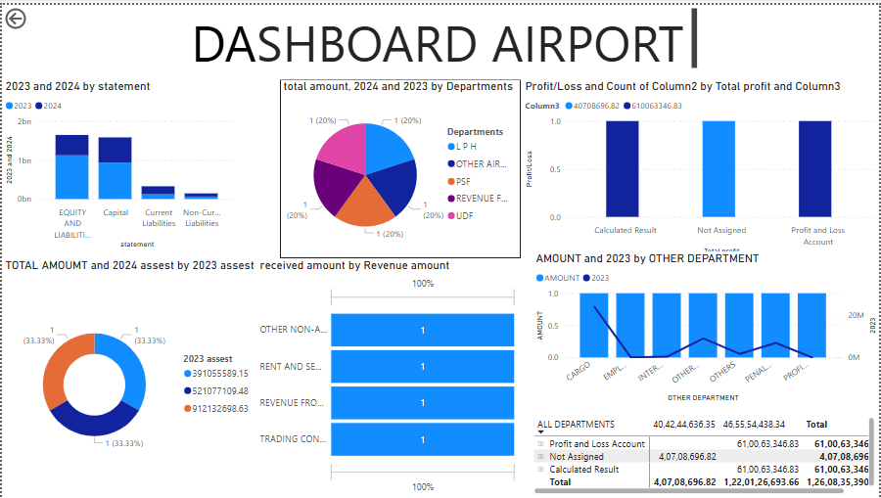

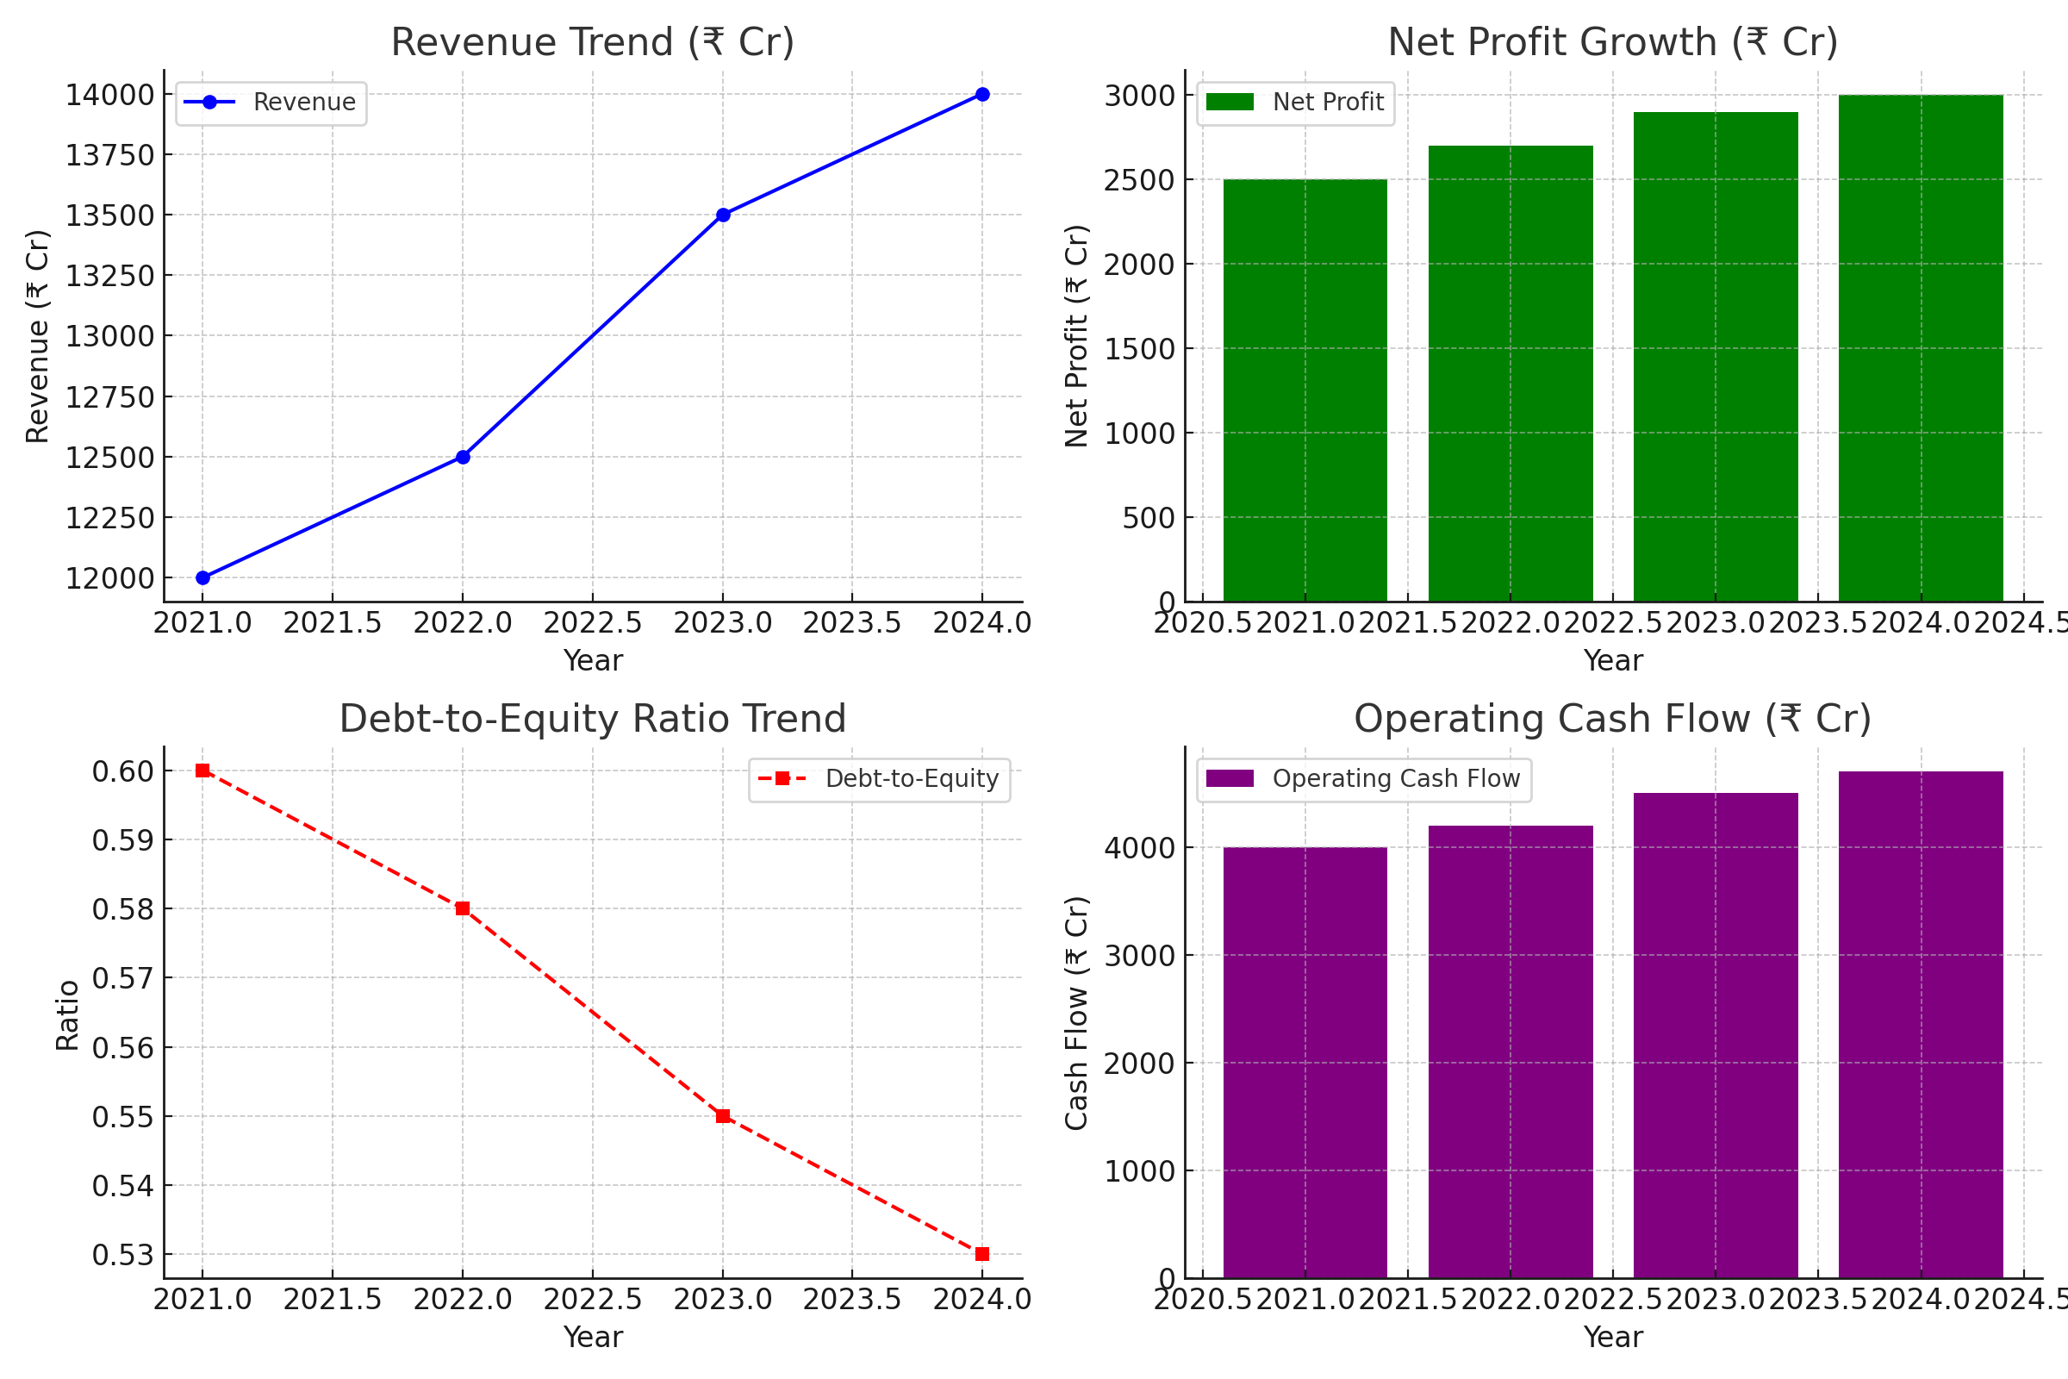

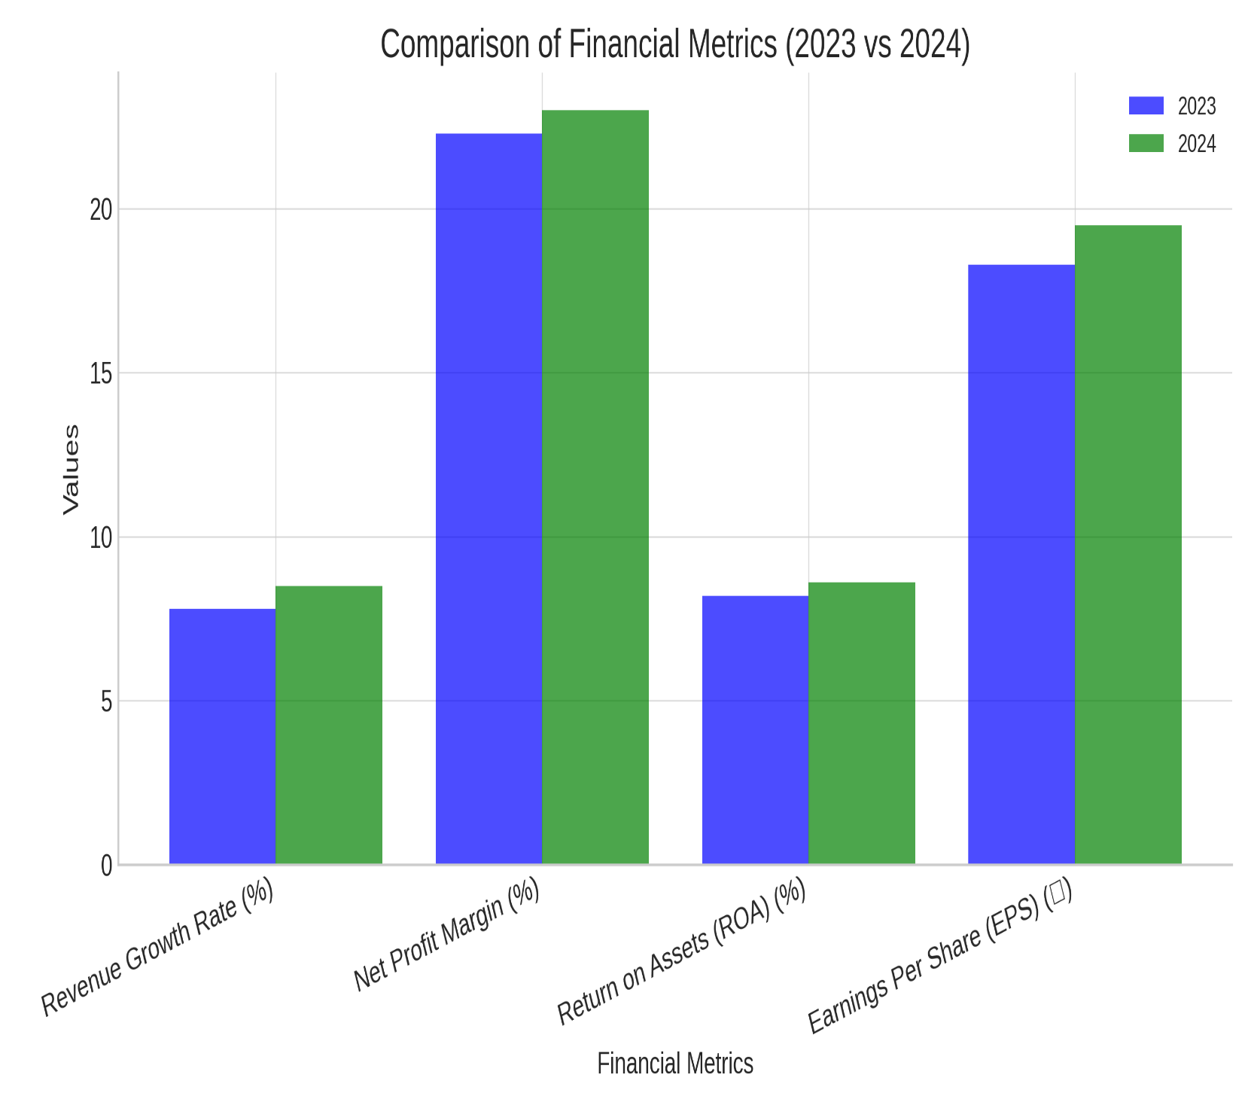

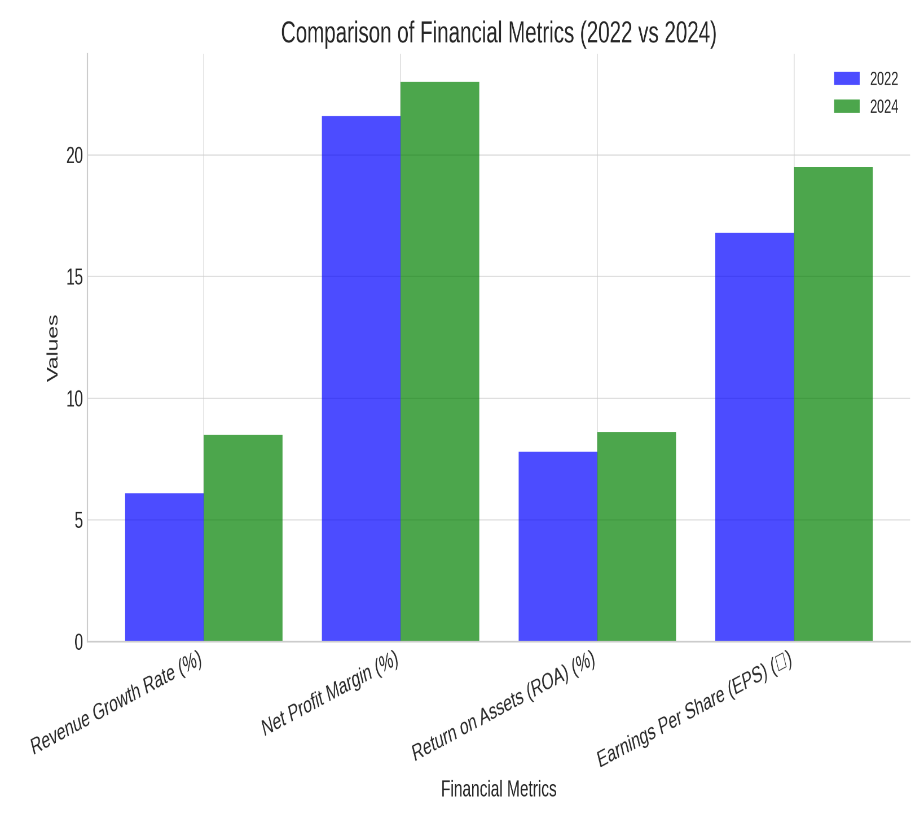

**Conclusion:**

A structured financial statement analysis provides deep insights into an entity’s financial health and future viability. Using a combination of trend analysis, ratio analysis, and cash flow examination, stakeholders can make informed financial and strategic decisions.

By following this structured methodology, financial statement analysis helps businesses and investors make informed decisions regarding financial performance, stability, and future growth. The financial analysis of AAI demonstrates its robust financial stability, attributed to its government support, diversified revenue streams, and strategic role in India’s aviation sector. While privatization and regulatory changes pose potential risks, AAI’s strong liquidity position and revenue generation capabilities help mitigate these concerns. Credit risk analysis indicates a low-to-moderate risk profile, ensuring AAI’s ability to meet financial obligations. The study highlights the importance of continuous financial monitoring and the use of advanced analytical tools for better decision-making. Overall, AAI’s financial management practices align with industry standards, ensuring sustainable growth and operational efficiency in the long run.

